COURSE: CLOUD AND NETWORK SECURITY _C1-2024
STUDENT NAME: LENNIE NTHIGA
STUDENT NO: cs-cns07-24170
OCTOMBER 15,2024

WEEK 5 ASSIGNMENT 2
Assignment 2: Configure ASA Basic Settings and Firewall Using the CLI

Contents
INTRDUCTION 3
NETWORK TOPOLOGY 3
Part 1: Verify Connectivity and Explore the ASA 4
Step 1: Verify connectivity. 4
Step 2: Determine the ASA version, interfaces, and license. 5
Step 3: Determine the file system and contents of flash memory. 5
Part 2: Configure ASA Settings and Interface Security Using the CLI 6
Step 1: Configure the hostname and domain name. 6
Step 2: Configure the enable mode password. 6
Step 3: Set the date and time. 6
Step 4: Configure the INSIDE and OUTSIDE interfaces. 6
Step 5: Test connectivity to the ASA. 7
Part 3: Configure Routing, Address Translation, and Inspection Policy Using the CLI 8
Step 1: Configure a static default route for the ASA. 8
Step 2: Configure address translation using PAT and network objects. 9
Part 4: Configure DHCP, AAA, and SSH 10
Step 1: Configure the ASA as a DHCP server. 10
Step 2: Configure AAA to use the local database for authentication. 11
Step 3: Configure remote access to the ASA. 11
Part 5: Configure a DMZ, Static NAT, and ACLs 12
Step 2: Configure static NAT to the DMZ server using a network object. 13
Step 3: Configure an ACL to allow access to the DMZ server from the Internet. 13
Step 4: Test access to the DMZ server. 14
CONCLUSION 15

INTRDUCTION
We would be going through ASA(adaptive security appliance) another security feature/device that can be placed between the client’s network/web server and the internet. Mostly used for smaller scale businesses .The Advantage of this being specialised in robust number of security features . It can be used to stop the traffic from outside sources from making ,packet filtering ,firewall setups and more. ASA is more of a firewall
IT provides:
- Dynamic routing and site to site vpn
- Offers ips and unified communications capabilities
- increase capacity and improve performance through high-performance, multi-site, multi-node clustering
- Provides collaboration between physical and virtual devices
The Cisco ASA can be replaced in place with firepower threat defence FTD which functions similarly and improved used in a larger network

NETWORK TOPOLOGY
The company has hired an administrator from a network management company to remotely manage the organizations network that is PC-B .
R1 would be the organizations router that’s is connected to the isp .
R2 being the isp router acting as the intermediary internet router.
R3 representing the isp that connects the network management company
The ISP assigned the public IP address space of 209.165.200.224/29
The ASA device is used by the organization to connects the internal corporate network and DMZ to the ISP while providing NAT and DHCP services to inside hosts
The DMZ SERVE is Demarcation Zone or Demilitarized Zone is a server kept in place for the purpose of the external users who want to access the organization data that the organization wants to provide to the external users but does not save the organizations sensitive data there
That’s where the ASA provides the ISP with a public Ip address for external users to access known as an OUTBOUND and an INBOUND a private Ip address for the organization to place the data in the DMZ server
In reference of https://www.cisco.com/c/dam/assets/sol/sb/isa500_emulator/help/guide/ad1681599.html#:~:text=About%20DMZ%20networks&text=The%20DMZ%20configuration%20is%20identical,configured%20on%20the%20security%20appliance.
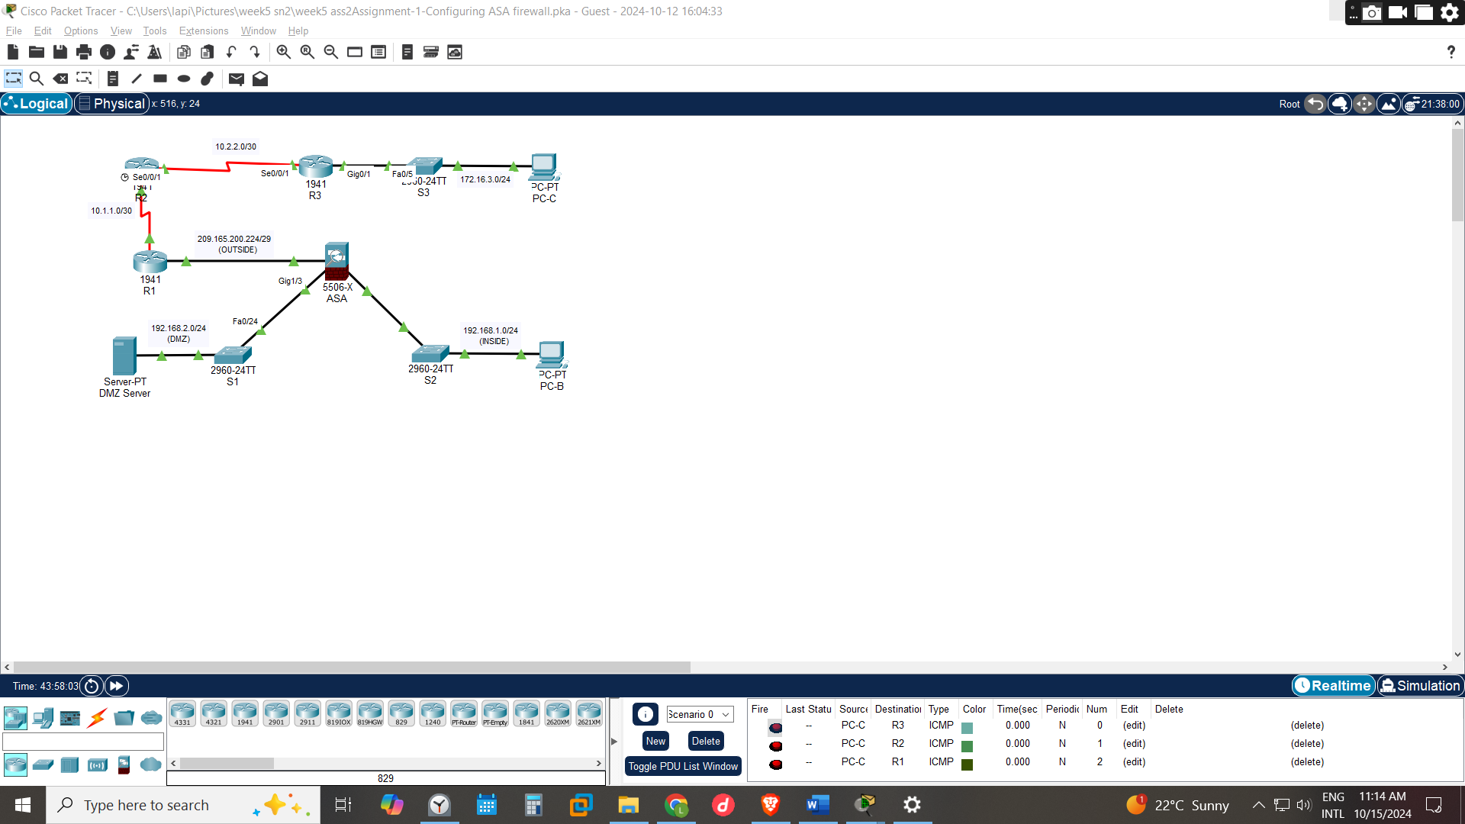

Part 1: Verify Connectivity and Explore the ASA

Step 1: Verify connectivity.
We can ping PC-C from R1(172.16.3.3) thus the routers can successfully connect however , can’t connect the DMZ server from the browser(209.165.200.227)
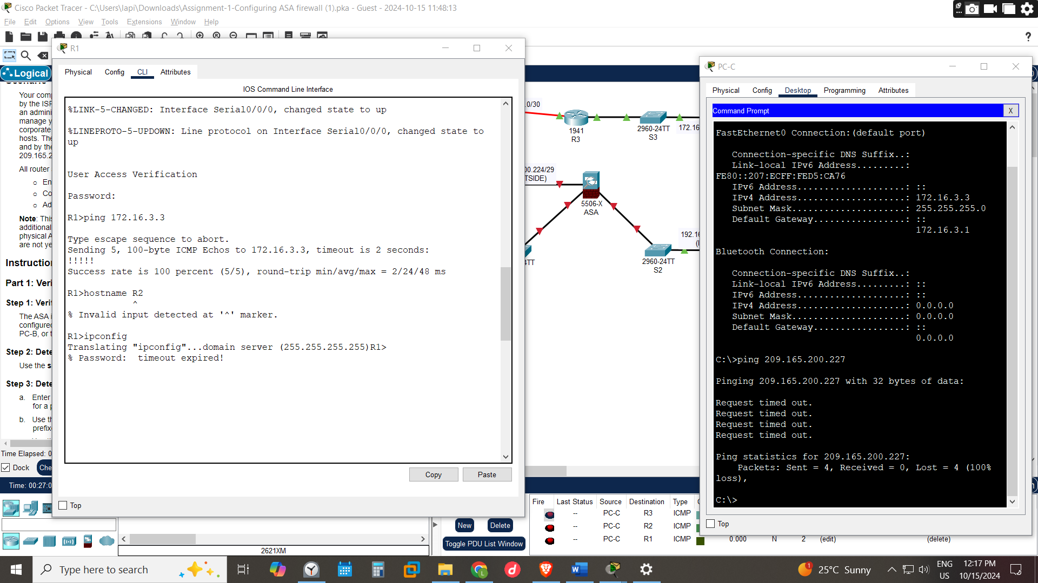

Step 2: Determine the ASA version, interfaces, and license.
Can be found by running show version

Step 3: Determine the file system and contents of flash memory.
Can be found by running show file system and show flash
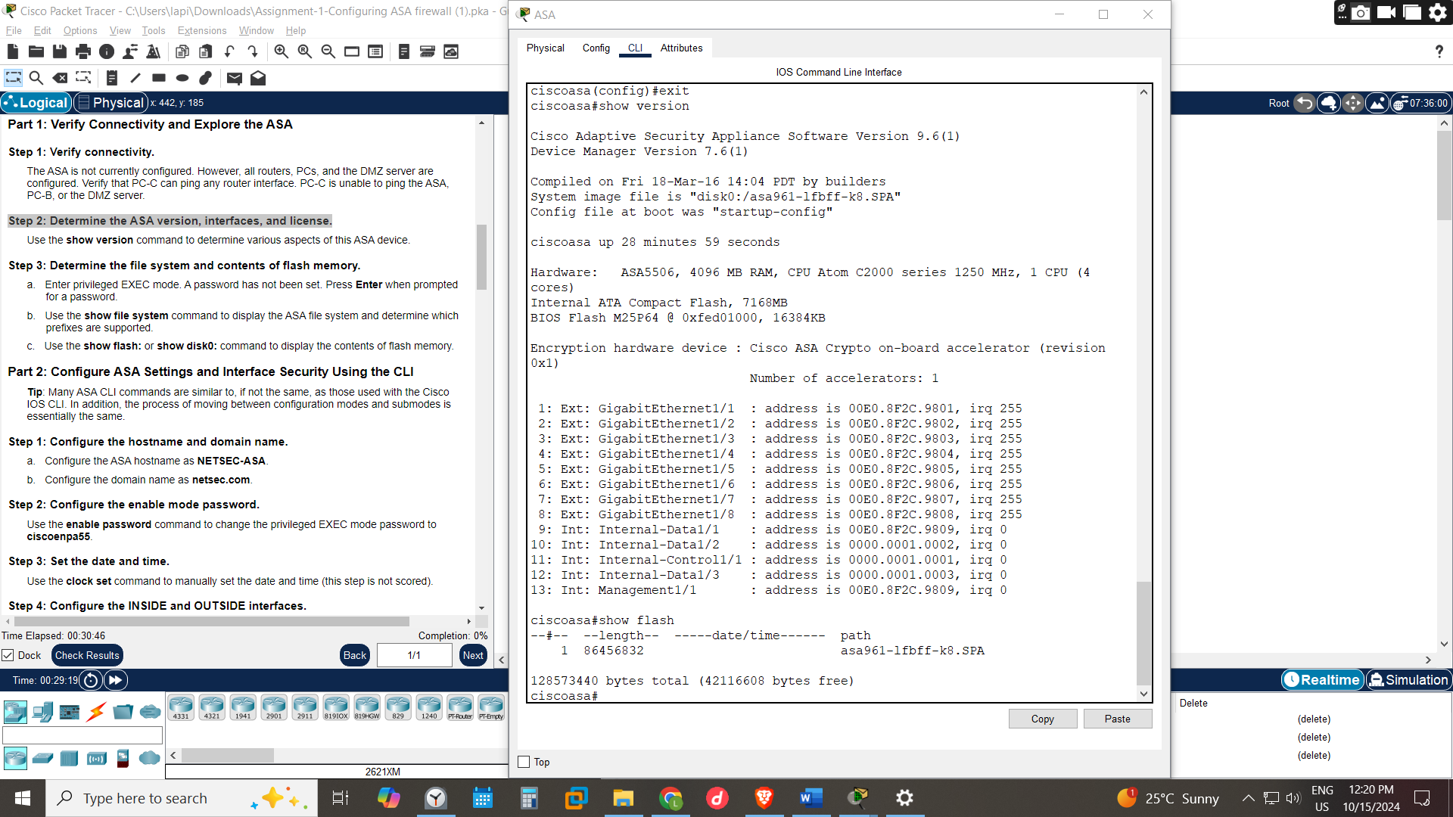

Part 2: Configure ASA Settings and Interface Security Using the CLI

Step 1: Configure the hostname and domain name.
Can be done by running hostname NETSEC-ASA
domain-name netsec.com

Step 2: Configure the enable mode password.
Can be done by running enable password ciscoenpa55

Step 3: Set the date and time.
Can be done by running clock set 12:31:00 10 October 2024

Step 4: Configure the INSIDE and OUTSIDE interfaces.
The ASA having a connection from the organizations pc that PC-B through interface G1/2(INSIDE) another connection to the DMZ SERVER G1/3 and another connected interface to then ISP router G1/1(OUTSIDE)
G1/1 OUTSIDE would be configured with the Ip address 209.165.200.226 255.255.255.248
And security level 0 meaning the ASA enforces stricter controls on incoming traffic, requiring explicit permissions
G1/2 would be configured with Ip 192.168.1.1 255.255.255.0 and security level 100 meaning it’s the most trusted interface, which is the inside network
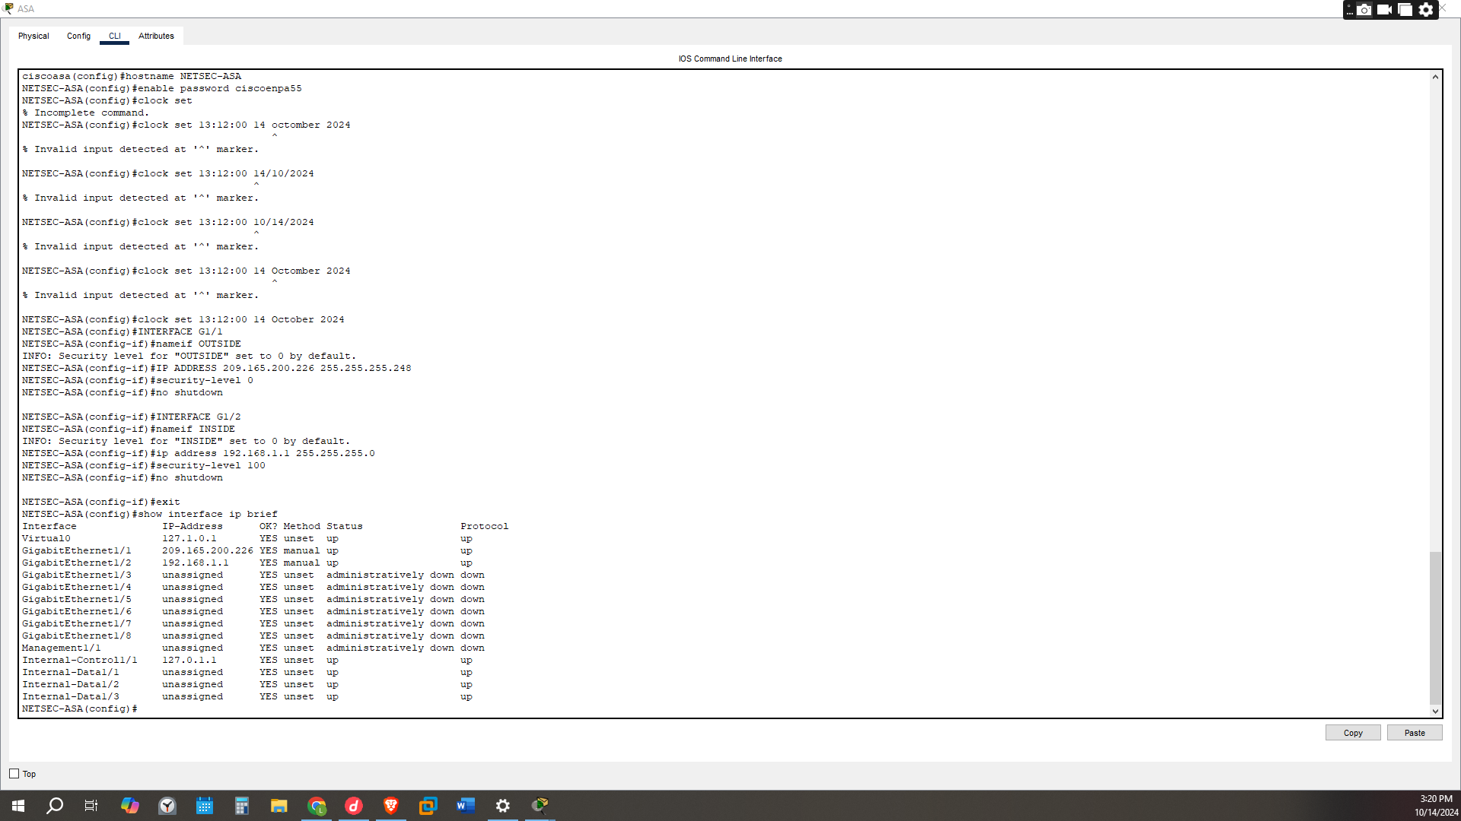

Step 5: Test connectivity to the ASA.
Pinging the ASA interface G1/1 interface Ip 192.168.1.1 was successful
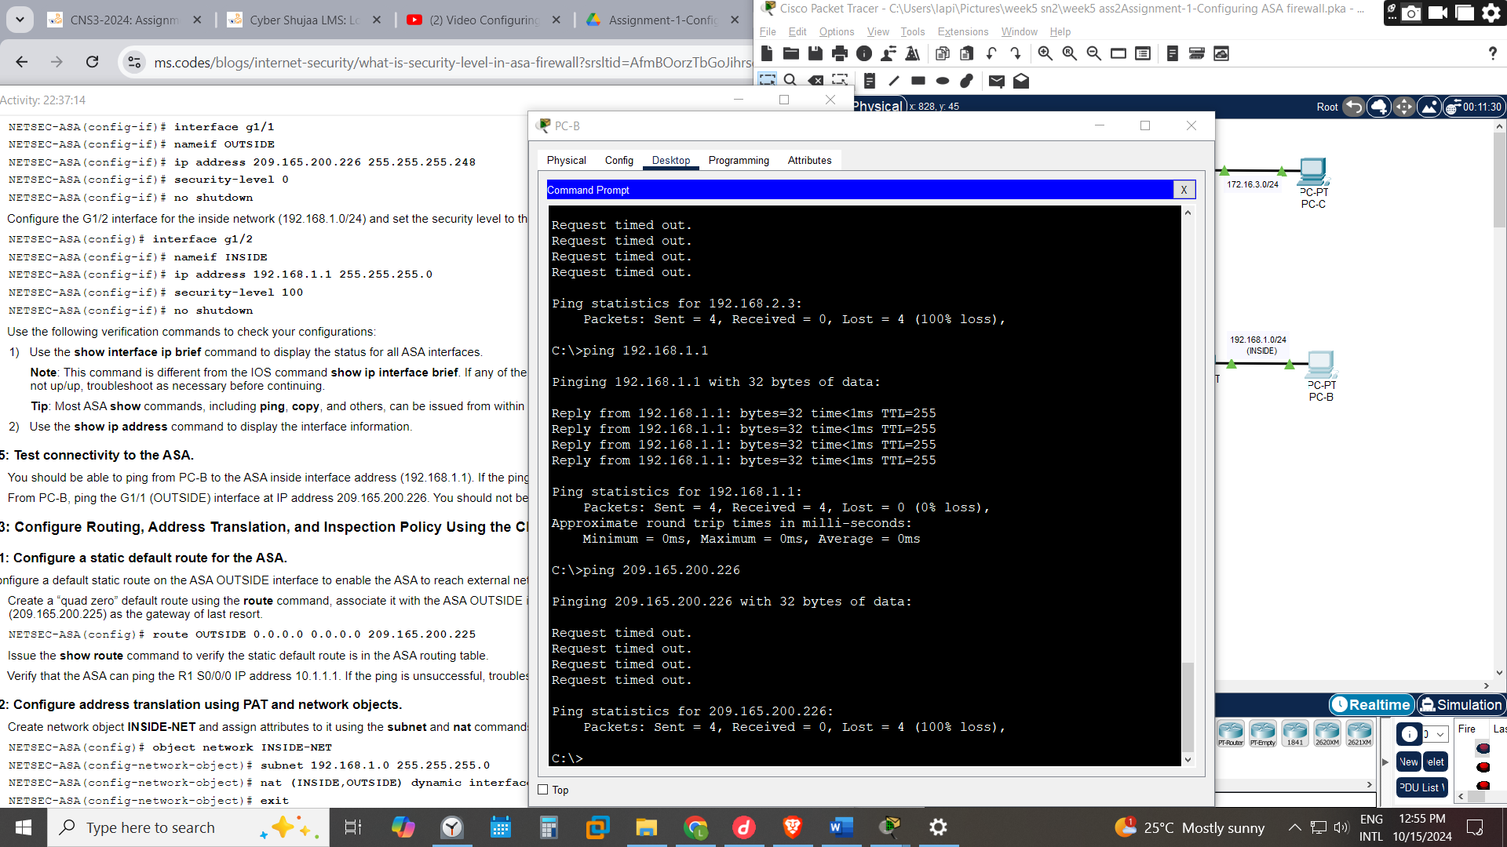

Part 3: Configure Routing, Address Translation, and Inspection Policy Using the CLI

Step 1: Configure a static default route for the ASA.
Routing is the process of selecting and defining paths for IP-packet traffic within or between networks as well as the process of managing network traffic overall
To route traffic to a nonconnected host or network, you must define a static route to the host or network or, at a minimum, a default route for any networks to which the ASA is not directly connected
Create a “quad zero” default route using the route command, associate it with the ASA OUTSIDE interface, and point to the R1 G0/0 IP address (209.165.200.225) as the gateway of last resort
- route OUTSIDE 0.0.0.0 0.0.0.0 209.165.200.225 -meaning destination of 0.0.0.0 with a subnet mask of 0.0.0.0 indicates a default route, meaning that any traffic not matching a more specific route will use this one. The 209.165.200.225 is the next-hop IP address for the default route should be the IP address of the next device that the ASA will forward packets to when no other routes are matched.

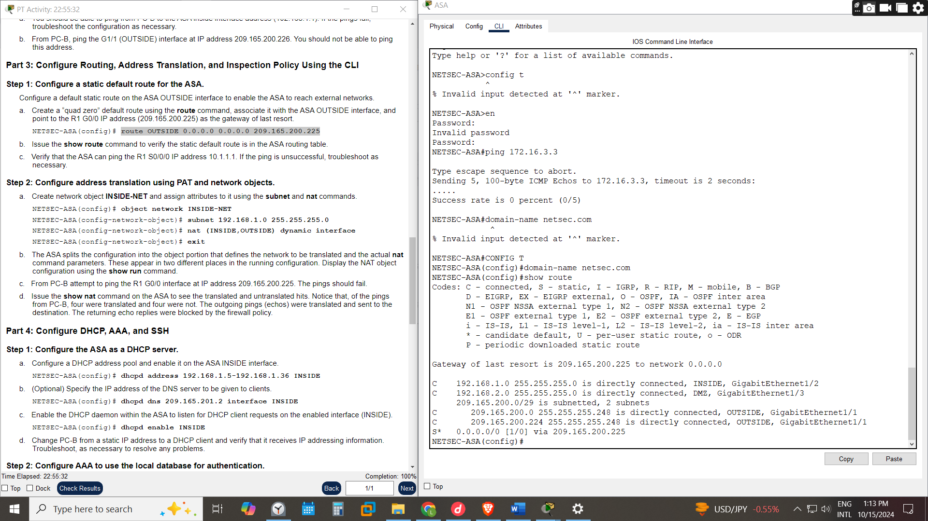

Step 2: Configure address translation using PAT and network objects.
NAT stands for network address translation. It's a way to map multiple private addresses inside a local network to a public IP address before transferring the information onto the internet.
PAT port Address Translator is a way a single public IP address is used for all internal private IP addresses, but a different port is assigned to each private IP address
- object network INSIDE-NET- objects allow you to abstract IP addresses and subnets into meaningful names, making configurations easier to read and manage.
- subnet 192.168.1.0 255.255.255.0
- Nat (INSIDE,OUTSIDE) dynamic interface – this activates the PAT in the ASA ,creating a dynamic NAT rule that translates all traffic from the INSIDE interface to the OUTSIDE interface using the IP address of the OUTSIDE interface.
Thus, the ASA will automatically handle port translations, allowing multiple internal hosts to be translated to the same public IP because of the word interface.
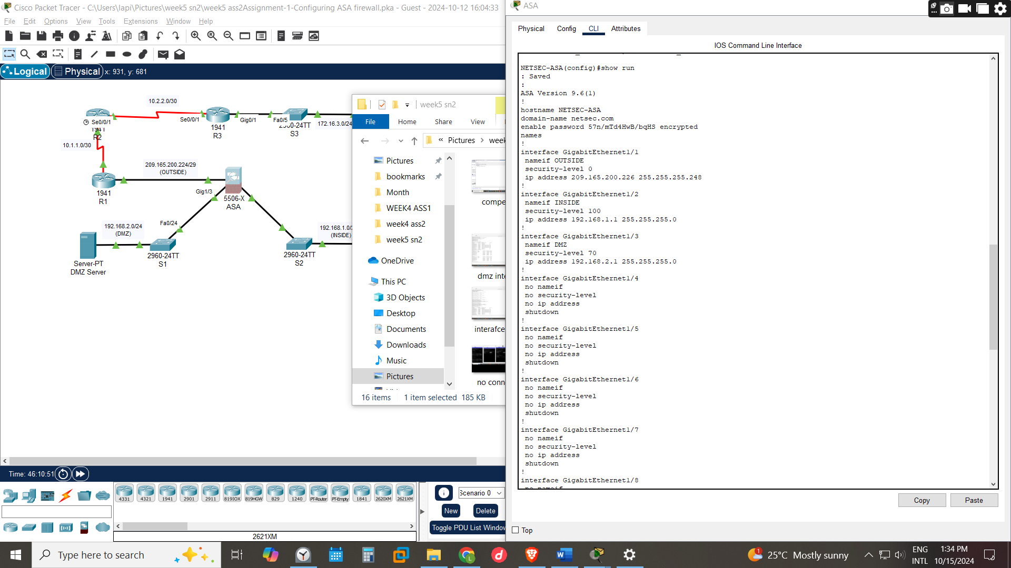
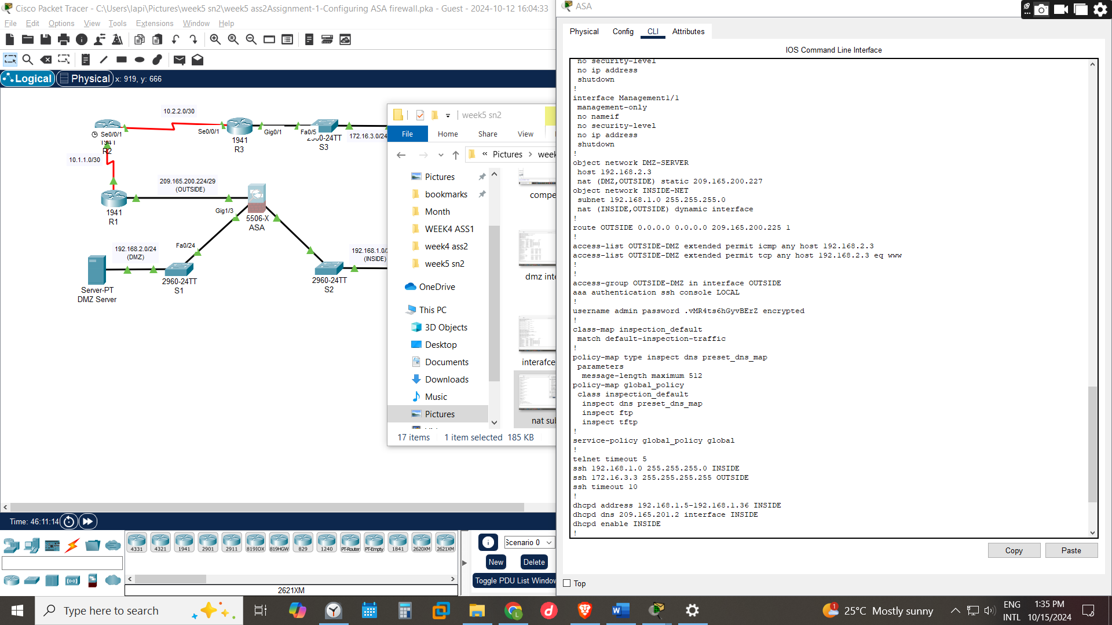

Part 4: Configure DHCP, AAA, and SSH

Step 1: Configure the ASA as a DHCP server.
We would configure the ASA to be the dhcp server that would be assigning Ip addresses
- a. Configure a DHCP address pool and enable it on the ASA INSIDE interface. dhcpd address 192.168.1.5-192.168.1.36 INSIDE
- b. (Optional) Specify the IP address of the DNS server to be given to clients. dhcpd dns 209.165.201.2 interface INSIDE
- c. Enable the DHCP daemon within the ASA to listen for DHCP client requests on the enabled interface (INSIDE). dhcp enable INSIDE

Step 2: Configure AAA to use the local database for authentication.
AAA-is authentication, authorisation accounting used in network security to control access to network resources and track user activities .commonly used in RADIUS server.
a. Define a local user named admin by entering the username command. Specify a password of adminpa55.
username admin password adminpa55
b. Configure AAA to use the local ASA database for SSH user authentication.
AAA authentication ssh console LOCAL
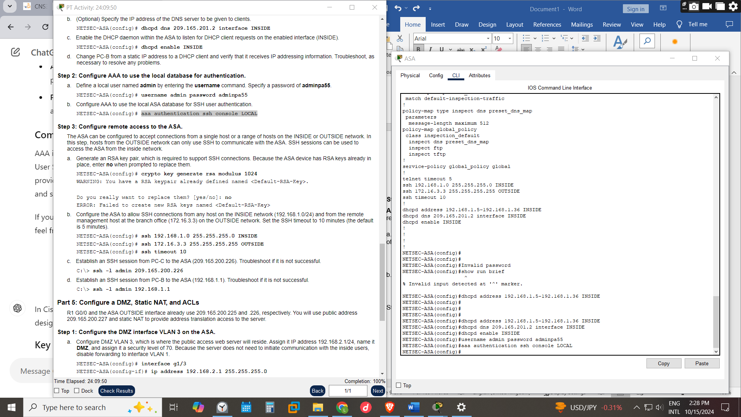

Step 3: Configure remote access to the ASA.
This config would allow the ousted host to communicate the ASA using ssh sessions
a. Generate an RSA key pair, which is required to support SSH connections. Because the ASA device has RSA keys already in place, enter no when prompted to replace them.
crypto key generates rsa modulus 1024
b. Configure the ASA to allow SSH connections from any host on the INSIDE network (192.168.1.0/24) and from the remote management host at the branch office (172.16.3.3) on the OUTSIDE network. Set the SSH timeout to 10 minutes (the default is 5 minutes).
ssh 192.168.1.0 255.255.255.0 INSIDE
ssh 172.16.3.3 255.255.255.255 OUTSIDE
ssh timeout 10
Establish an SSH session from PC-C to the ASA (209.165.200.226). PC-B to the ASA (192.168.1.1)
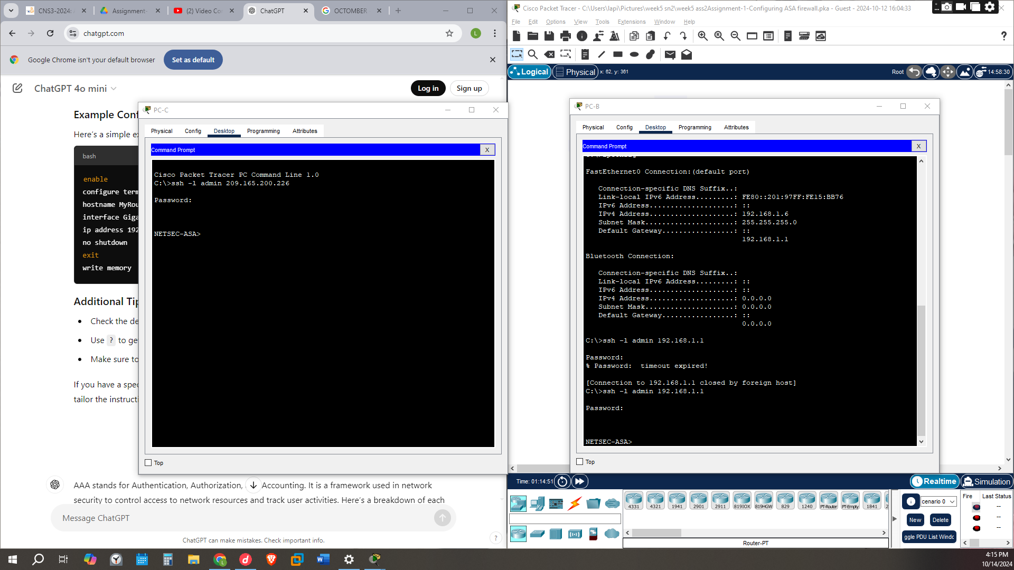

Part 5: Configure a DMZ, Static NAT, and ACLs
The DMZ SERVE is Demarcation Zone or Demilitarized Zone is a server kept in place for the purpose of the external users who want to access the organization data that the organization wants to provide to the external users but does not save the organizations sensitive data there
- Configure DMZ VLAN 3, which is where the public access web server will reside. Assign it IP address 192.168.2.1/24, name its DMZ, and assign it a security level of 70. Because the server does not need to initiate communication with the inside users, disable forwarding to interface VLAN 1.
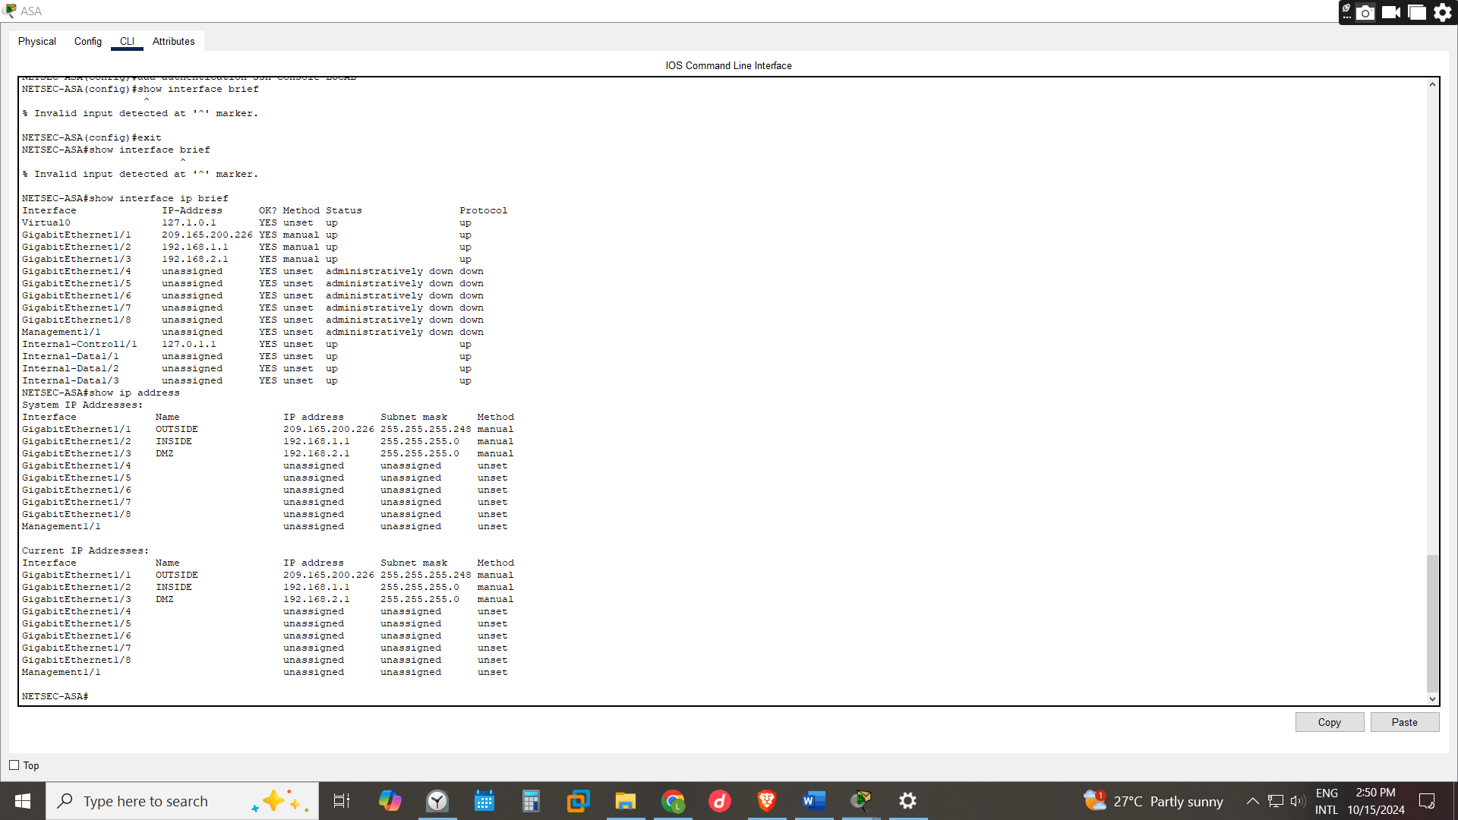

Step 2: Configure static NAT to the DMZ server using a network object.
The static NAT would be setup to allow the external users to access services from the DMZ server
Configure a network object named DMZ-SERVER and assign it the static IP address of the DMZ server (192.168.2.3). While in object definition mode, use the NAT command to specify that this object is used to translate a DMZ address to an OUTSIDE address using static NAT, and specify a public translated address of 209.165.200.227.

Step 3: Configure an ACL to allow access to the DMZ server from the Internet.
Configure a named access list OUTSIDE-DMZ that permits the TCP protocol on port 80 from any external host to the internal IP address of the DMZ server. Apply the access list to the ASA OUTSIDE interface in the “IN” direction.
ACL-Access control list is made up of rules that either allow access to a computer environment or deny it.
access-list OUTSIDE-DMZ permit icmp any host 192.168.2.3 -gives permission for users to send ICMP traffic to 192.168.2.3
access-list OUTSIDE-DMZ permit tcp any host 192.168.2.3 eq 80 - This setup allows external users to access the DMZ server at 192.168.2.3 on port 80 for HTTP traffic
access-group OUTSIDE-DMZ in interface OUTSIDE- contains rules that control the traffic allowed or denied to and from the OUTSIDE interface specifically applied on the incoming traffic on the OUTSIDE interface
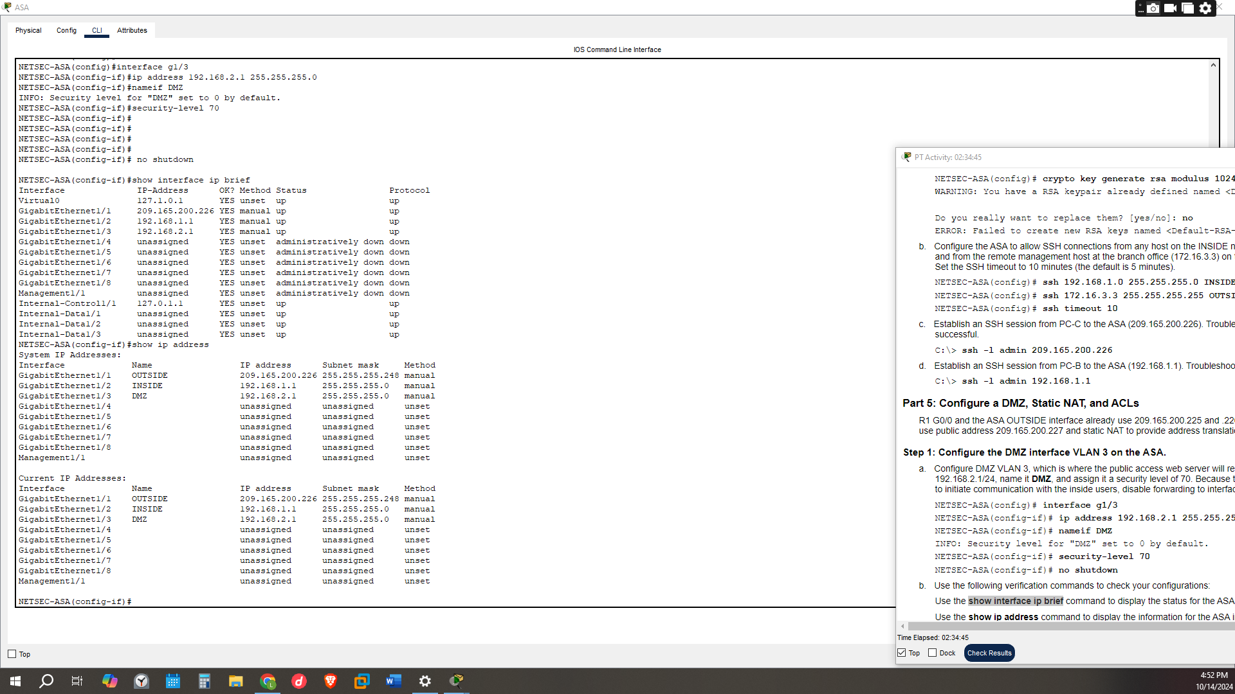

Step 4: Test access to the DMZ server.
We would type the Ip 209.165.200.227 in the PC-C browser to access the DMZ server in which would be successful compared to the past trial in the beginning
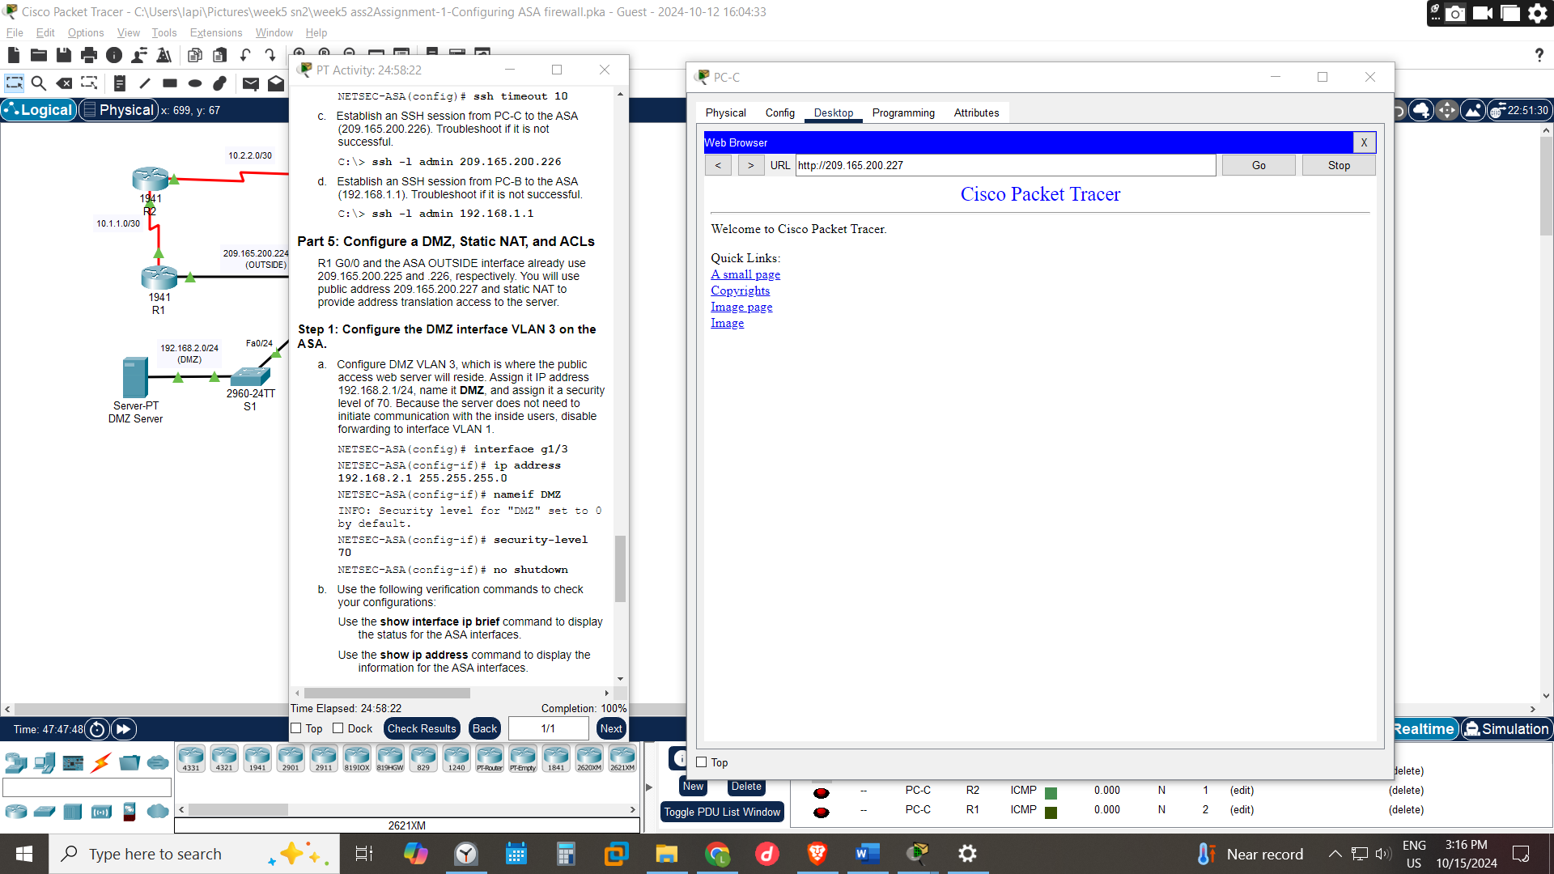

CONCLUSION

It’s evident that since most businesses have started migrating their operations to be done remotely and market places being done online there been a growth of need to accessing a company’s server thus by having devices such as ASA and DMZ servers shows the security steps that can prevent attack
By having such setups protects the employees from the outside networks and the sensitive data from being access by public users in reference of https://www.cisco.com/c/en/us/td/docs/security/asa/asa922/configuration/firewall/asa-922-firewall-config/intro-fw-services.html
By using ASA one can make more configurations such as:
- Firewall services for virtual machines
- URL filtering for the internal users can be used to block sites and IPS from being accesses by employees to reduce chances of accessing unwanted sites or even to reduce distractions
- It a conduct application inspection by conducting deep packet inspections of the open ports and protocols
- ASA uses the ISAKP Internet Security Association and Key Management Protocol and IPsec Internet Protocol Security tunnelling standards to create band manage tunnels securely for remote users

COMPELTION POST
